Crimson Year, Github Daily Operations

During this project it’s critical you don’t make any changes to the “main” branch directly. This guide will help us work together as a team and allow us to not step on each others toes.

First things first, let’s sync the Github cloud with our local repository. Click “Fetch Origin” and then “Pull origin” if there are any commits in the cloud that you don’t have locally.
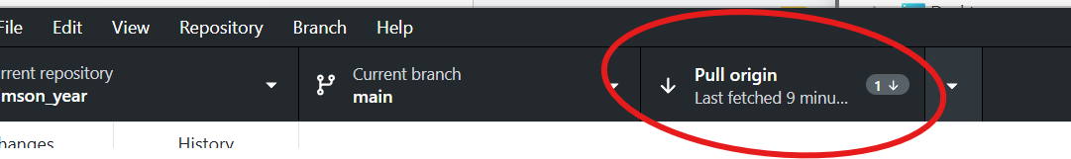

Before making any edits, create a branch and title it relevant to the feature you’re working on. Generally this is done with all lower case letters and dashes to separate words (Example: “test-feature”)
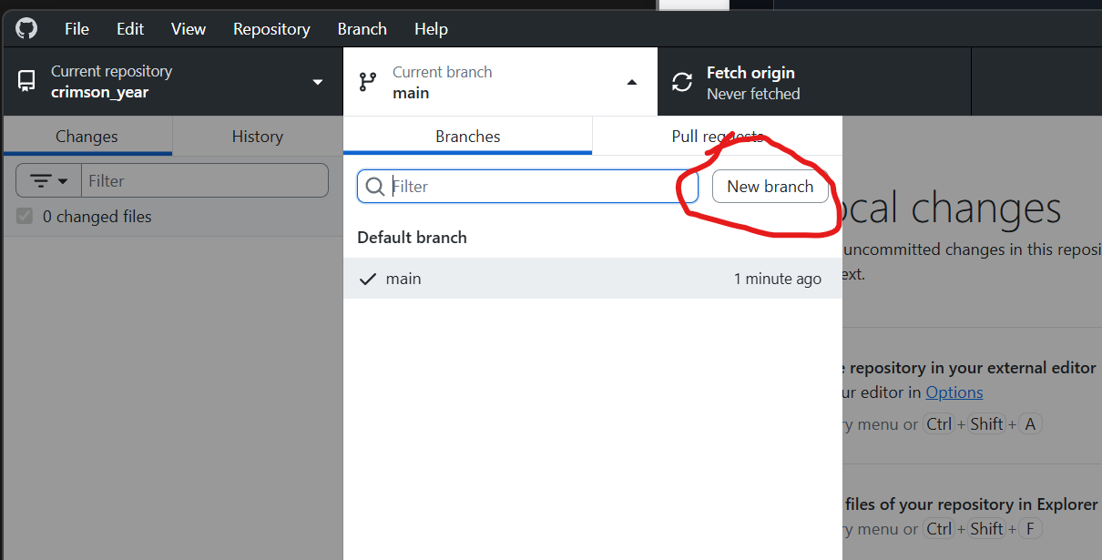
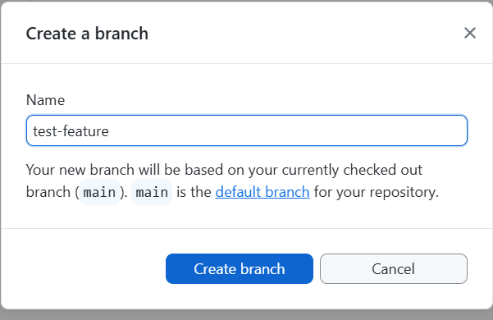
You can double check at the top that you’re not on main anymore.
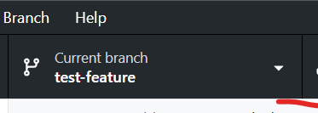
Next, you’ll want to be utilizing the “latest from main”, which would include anything anyone has merged from their own branch. In order to do this, at the top select Branch -> update from main. You can do this as often as you like and should at least be done at the beginning of the day.
This may result in merge conflicts however, please see the merge conflict guide.
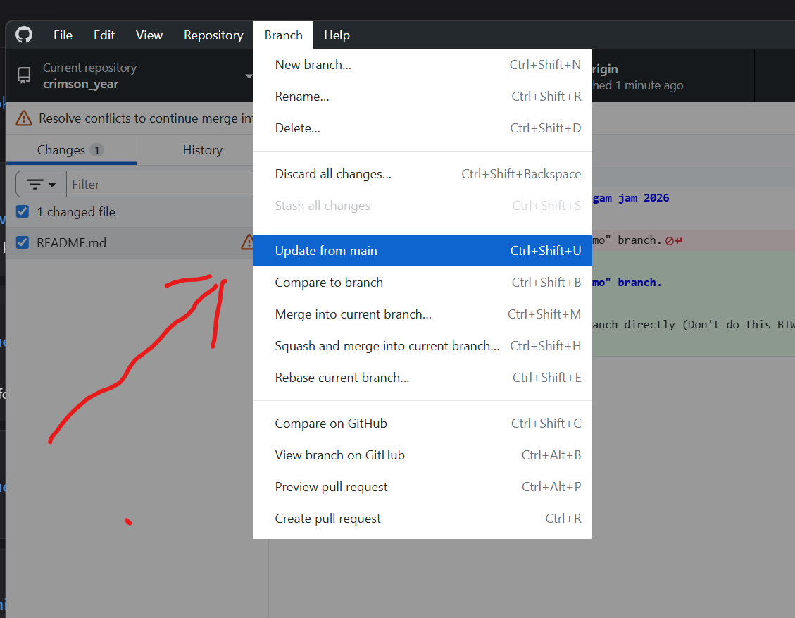
You’re now free to make edits as you see fit. Add files or work in the game engine.
You can now commit and publish your changes to “Origin” (which is the Github cloud). You’ll want to do this often, but at least once a day (at the end of doing work):
- Commit
  - 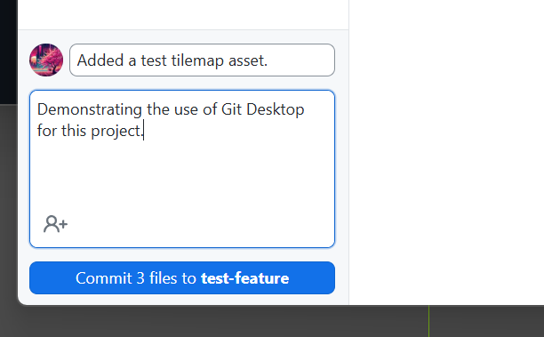
- Publish
  - 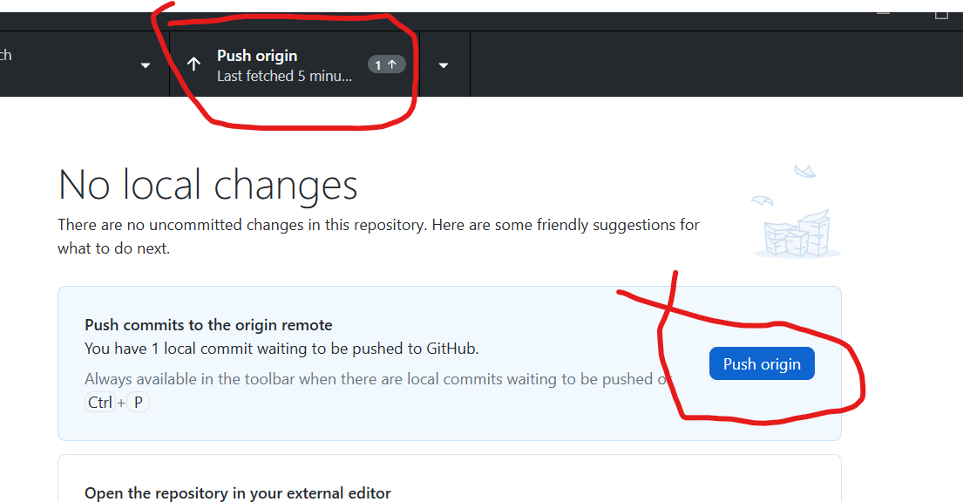

When your feature is ready to be passed to the rest of the team you can perform a pull request.
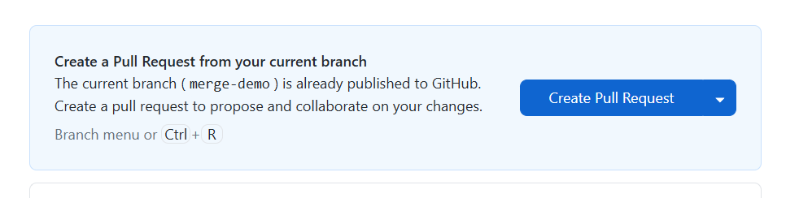
You can go ahead and merge the changes in if you want, or have the team review your changes first.
After your feature branch is merged delete the branch and head back to the top of this document to start a new feature.
